6. Flight Control Software Architecture

6.1 Introduction
The Model Rocket Flight Control Software (MR FSW) is responsible for managing all onboard operations during the mission lifecycle, including sensor initialization, telemetry handling, flight-state management, data logging, payload deployment logic, and recovery assistance. The software is implemented as a Finite State Machine (FSM) to ensure deterministic behaviour, modularity, and safe execution during all mission phases.
The flight software continuously interfaces with the onboard sensors, telemetry subsystem, SD-card storage, and payload separation mechanisms. The FSM architecture allows the model rocket to autonomously transition between mission phases based on real-time sensor data and predefined logical conditions.
The software architecture has been designed in accordance with the IN-SPACe Model Rocketry India Student Competition 2026 guidelines, which mandate: real-time telemetry transmission at 1 Hz or greater, onboard telemetry backup storage, flight software state indication, recovery from processor reset, payload separation at the target altitude (1000m ± 100m), descent control activation, and telemetry-based mission monitoring.
The onboard flight software operates on the primary STM32 flight computer and communicates with all onboard sensors through I2C, SPI, and UART interfaces. The software continuously acquires altitude, atmospheric pressure, temperature, acceleration, angular velocity, GNSS coordinates, system voltage, and flight-state information. It interfaces with two independent altimeters to ensure redundant and fail-safe recovery operations:
- Primary Altimeter: A COTS-based barometric sensor integrated into the primary avionics flight computer loop for real-time state estimation and telemetry logging.
- Backup Altimeter: A redundant, independent COTS altimeter (provided by the InSpace authorities) integrated into the redundant separation chain to trigger payload separation and parachute ejection if the primary system fails.
All telemetry packets are serialized into ASCII comma-separated format and transmitted to the Ground Control Station (GCS) through the RF telemetry subsystem (LoRa) while simultaneously being stored onboard for redundancy.

6.2 Finite State Machine (FSM)
The Model Rocket flight software is implemented using a Finite State Machine consisting of the following operational states: BOOT, TEST_MODE, LAUNCH_PAD, ASCENT, PAYLOAD_SEP, DESCENT, AEROBREAK_RELEASE, IMPACT.
The FSM architecture ensures structured mission execution, safe subsystem activation, controlled deployment sequencing, and telemetry continuity. Each state performs dedicated operations and transitions to the next state only after specific conditions are satisfied.

6.2.1 BOOT State
The BOOT state is entered immediately after the external power switch of the model rocket is turned ON. During this phase, the onboard computer initializes all hardware and software subsystems, including: the MPU6050/BNO086 IMU, the primary BMP580/BMP585 pressure sensor, the NEO-M9N GNSS receiver, the RF telemetry module (LoRa/Zigbee), the SD-card storage, the voltage monitoring circuitry, and the recovery beacon circuitry.
The following tasks are performed during BOOT: sensor initialization, communication bus initialization, SD-card mounting, loading previous state information, telemetry initialization, and internal health diagnostics.
The software checks sensor communication status, telemetry subsystem availability, SD-card accessibility, and power-system health. If any critical subsystem fails initialization, the software logs the error to onboard storage, attempts re-initialization once, and continues to TEST_MODE with the failed subsystem marked as unavailable.
The BOOT state also restores the previous mission state from onboard storage in the event of a processor reset during flight, ensuring compliance with mission requirements regarding state recovery after reboot.

6.2.2 TEST_MODE State
After successful initialization, the software transitions into TEST_MODE. The purpose of this state is to validate all onboard subsystems before launch.
During TEST_MODE: all sensors perform live-data acquisition, telemetry packets are generated, SD-card logging is tested, telemetry links are verified, and sensor values are checked for validity.
The system performs demo telemetry transmission, packet integrity validation, sensor availability checks, and communication verification with the Ground Control Station.
If any abnormality is detected, the system logs an error code to onboard storage, transmits the error through telemetry, and continues to LAUNCH_PAD with degraded functionality noted. If all checks pass successfully, the software transitions into the LAUNCH_PAD state.

6.2.3 LAUNCH_PAD State
The LAUNCH_PAD state represents the pre-launch operational phase. During this phase: all sensors remain active, telemetry transmission begins at 1 Hz, and calibration commands may be received from the Ground Control Station.
The following calibrations are performed: gyroscope zero-offset calibration, barometric pressure calibration, accelerometer bias calibration, and launch-pad altitude reference calibration. The launch-pad altitude is defined as the zero-reference altitude for the mission.
Telemetry data and current FSM state are periodically written to onboard storage to enable state recovery after reset. The software remains in this state until launch conditions are detected.

Launch Detection Logic
The transition from LAUNCH_PAD to ASCENT uses sensor cross-verification to improve reliability. The primary launch indicator is sudden sustained acceleration detected through the IMU. The secondary confirmation is positive altitude change detected by the primary barometric altimeter.
The transition logic is implemented as: acceleration magnitude exceeds a predefined threshold, sustained for a fixed time interval, and altitude rises above a small threshold value. This prevents false launch triggers caused by vibration, handling shock, or sensor noise.

6.2.4 ASCENT State
The ASCENT state begins once rocket launch has been confirmed. During this phase: all telemetry data is continuously transmitted, sensor data is logged to onboard storage, and real-time state information is sent to the Ground Control Station.
The flight computer collects altitude, pressure, temperature, GNSS coordinates, acceleration, angular velocity, and voltage data. All telemetry packets are serialized into comma-separated ASCII format before transmission over the RF telemetry channel. The ascent phase continues until apogee or ejection conditions are detected.

Apogee / Separation Detection
The transition from ASCENT to PAYLOAD_SEP is determined primarily using altitude trend analysis. The software continuously computes vertical velocity using consecutive altitude samples from the primary altimeter. When altitude reaches a peak and sustained negative vertical velocity is observed, the software confirms apogee. This method is more reliable than using accelerometer direction alone, as barometric altitude provides better long-term stability for apogee detection.
If the primary flight computer fails to detect apogee, the backup altimeter (provided by InSpace) operates in parallel on a redundant circuit to independently trigger the separation event.

6.2.5 PAYLOAD_SEP State
The PAYLOAD_SEP state is activated immediately upon apogee detection at the target altitude (1000m ± 100m). During this state, the flight computer initiates the payload separation and drogue parachute deployment sequence.
The software commands the servo actuator to release the mechanical latch of the spring ejection mechanism. This ejects the CAN-7U sized satellite (payload) and deploys the primary stage (drogue parachute) to stabilize the descent of the rocket. Telemetry transmission rates remain at 1 Hz, indicating payload separation status. Once deployment is confirmed via telemetry and sensor validation, the software transitions to the DESCENT state.

6.2.6 DESCENT State
The DESCENT state begins immediately after payload separation. During this state: the primary drogue parachute is active, the descent rate is monitored, and stabilization is achieved.
The primary parachute is intended to reduce tumbling, stabilize the model rocket body, and maintain telemetry link reliability. The parachute system is designed to maintain descent rates between 2 to 5 m/s (as mandated by guidelines). During this phase, sensor data fusion is used to continuously track altitude, descent speed, and orientation.

6.2.7 AEROBREAK_RELEASE State
The AEROBREAK_RELEASE state is activated when the rocket is in the DESCENT state and the altitude falls below a secondary threshold (600m ± 10m).
Once the activation condition is met, the secondary recovery or main parachute mechanism is deployed to further decelerate the rocket body for a safe landing. This state transition is strictly gated by the FSM to prevent accidental premature deployment during ascent or early descent. Sensor data continues to be logged and telemetered continuously.

6.2.8 IMPACT State
The IMPACT state represents touchdown and mission completion. This state is triggered using low-altitude detection combined with a sudden deceleration spike measured by the IMU. Typical conditions include altitude near ground level and a significant deceleration spike.
During IMPACT: the audio recovery beacon is activated, final telemetry packets are transmitted, and onboard data files are finalized. The recovery beacon assists in locating the rocket body. Future implementation may dynamically reduce beacon intensity based on GNSS proximity or radio signal strength to optimize post-landing power consumption.

Flow Chart showing change of states
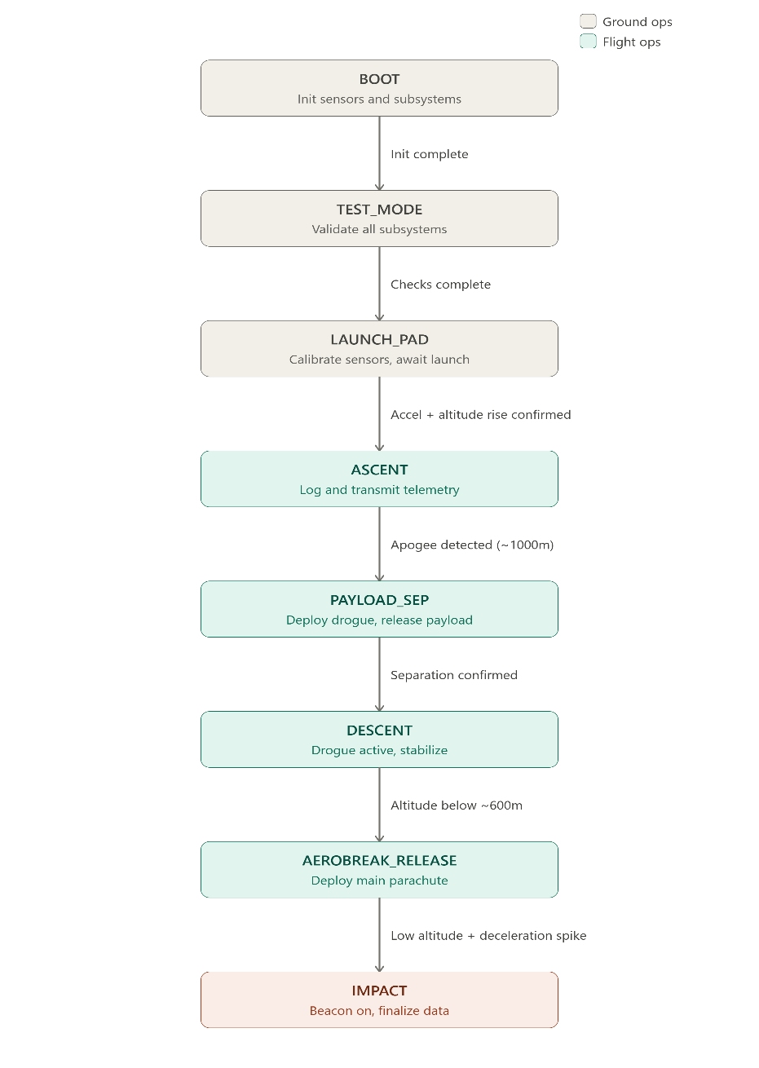

6.4 Software Architecture and Module Overview
- FSW Core: The main central controller of the entire model rocket system, acting as the OS that orchestrates all other modules. Maintains the state machine with a pointer to the currently executing state, decides when to move to the next state, and decides how to allocate CPU cycles, set sampling rates, and manage execution priority. Has master control over all other modules but also accepts inbound signals from them (aka interrupts in case of faults being raised).
- Data Layer: An abstraction layer that sits between raw sensor data and the decision logic in FSW Core. It contains data structures and functions that process higher-level interpretations of system state, for example, fusing accelerometer and altimeter readings to determine with high confidence whether the rocket is ascending, has reached apogee, or is descending.
- Hardware Controller Layer: Directly interfaces with all onboard sensors and hardware peripherals. Each hardware and avionic component has its own dedicated component submodule. It receives control signals asynchronously from FSW Core. Data acquisition strategy utilizes a shared memory model where each controller writes continuously to an assigned buffer that FSW polls, balancing latency and synchronization complexity.
- Communication Layer: Manages all external interfaces, primarily the ground station link. Responsible for receiving inbound commands from the ground station and relaying them to FSW Core for interpretation, and for serializing outgoing telemetry data into well-formed packets and forwarding them to the Hardware Controller for transmission.
- Configuration Module: A centralized configuration module, implemented as header files like config.h, that stores all magic numbers, decision thresholds, and tunable constants used across the system. It also includes shared types in types.h read by the FSW to initialize all submodules.
- TestAndSim Suite: Acts as a drop-in replacement for the Hardware Controller Layer during ground testing, feeding predefined or procedurally generated sensor data into the rest of the system. Simulated inputs include controlled randomness to stress-test decision logic, supporting both boundary-condition testing and blackbox testing of the full FSW pipeline without physical hardware.

Tasks overview for FreeRTOS
- TaskIMU: Periodically reads accelerometer, gyroscope, and attitude data from the BNO086 and updates the shared IMU buffer. Sampling rate is controlled dynamically by FSWCore.
- TaskBaro: Periodically reads BMP580/BMP585 pressure and temperature data, computes altitude estimates, and updates the shared barometric buffer. Sampling rate is controlled dynamically by FSWCore.
- TaskGNSS: Parses UBX-NAV-PVT data from the NEO-M9N and updates the shared GNSS buffer with position, altitude, UTC time, satellite count, and fix validity.
- TaskDataLayer: Fuses IMU and barometric data from the primary altimeter to estimate altitude and vertical velocity, evaluates flight condition flags, and updates the shared AbstractState buffer.
- TaskFSM: Main 10 Hz orchestration task managing FSM transitions, command handling, watchdog feeding, deployment actions, task rate notifications, and state persistence.
- TaskTelemetry: Builds telemetry packets from shared system data, transmits them over the RF link (LoRa/Zigbee), queues them for SD logging, and opens the radio receive window.
- TaskCommRx: Waits for the RF transceiver to receive interrupts, validates incoming packets, forwards valid commands to FSWCore, and sends ACK responses.
- TaskSDWrite: Writes telemetry and state data to the SD card, ensures persistent storage with flushing, and reports storage faults non-fatally.
- TaskHealthMonitor: Runs at 1 Hz to monitor voltage and system faults, logs fault events, and updates telemetry fault flags.
- TaskRecoveryBeacon: Remains dormant until the FSM transitions to the IMPACT state, then activates the audio beacon and periodically transmits the final GPS recovery coordinates over the RF link before suspending permanently.

Sampling Rate for various tasks:
Task | Module | BOOT | TEST | LAUNCH_PAD | ASCENT | PAYLOAD_SEP | DESCENT | AEROBREAK_RELEASE | IMPACT
TaskIMU | HardwareController | 10 Hz | 10 Hz | 10 Hz | 100 Hz | 50 Hz | 100 Hz | 100 Hz | 10 Hz
TaskBaro | HardwareController | 5 Hz | 5 Hz | 5 Hz | 20 Hz | 10 Hz | 20 Hz | 20 Hz | 2 Hz
TaskGNSS | HardwareController | 1 Hz | 1 Hz | 5 Hz | 5 Hz | 5 Hz | 5 Hz | 5 Hz | 1 Hz
TaskDataLayer | DataLayer | 5 Hz | 5 Hz | 5 Hz | 20 Hz | 10 Hz | 20 Hz | 20 Hz | 2 Hz
TaskFSM | FSWCore | 10 Hz | 10 Hz | 10 Hz | 10 Hz | 10 Hz | 10 Hz | 10 Hz | 10 Hz
TaskHealthMonitor | FSWCore | 1 Hz | 1 Hz | 1 Hz | 1 Hz | 1 Hz | 1 Hz | 1 Hz | 1 Hz
TaskTelemetry | CommLayer | off | off | 1 Hz* | 1 Hz | 1 Hz | 1 Hz | 1 Hz | final TX
TaskCommRx | CommLayer | off | off | intr. | intr. | intr. | intr. | intr. | off
TaskSDWrite | HardwareController | 1 Hz | 1 Hz | 1 Hz | 1 Hz | 1 Hz | 1 Hz | 1 Hz | finalise
TaskRecoveryBeacon | CommLayer | dormant | dormant | dormant | dormant | dormant | dormant | dormant | once

* TaskTelemetry activates on CMD_START_TELEMETRY from GCS, expected during LAUNCH_PAD.
* TaskFSM and TaskHealthMonitor hold constant rate across all states.
* All other periodic tasks updated by FSWCore via xTaskNotify on each state transition.
* Interrupt driven (RX-done ISR), no fixed rate.

Sequencing diagrams for the various tasks are on the next page with a high level overview.
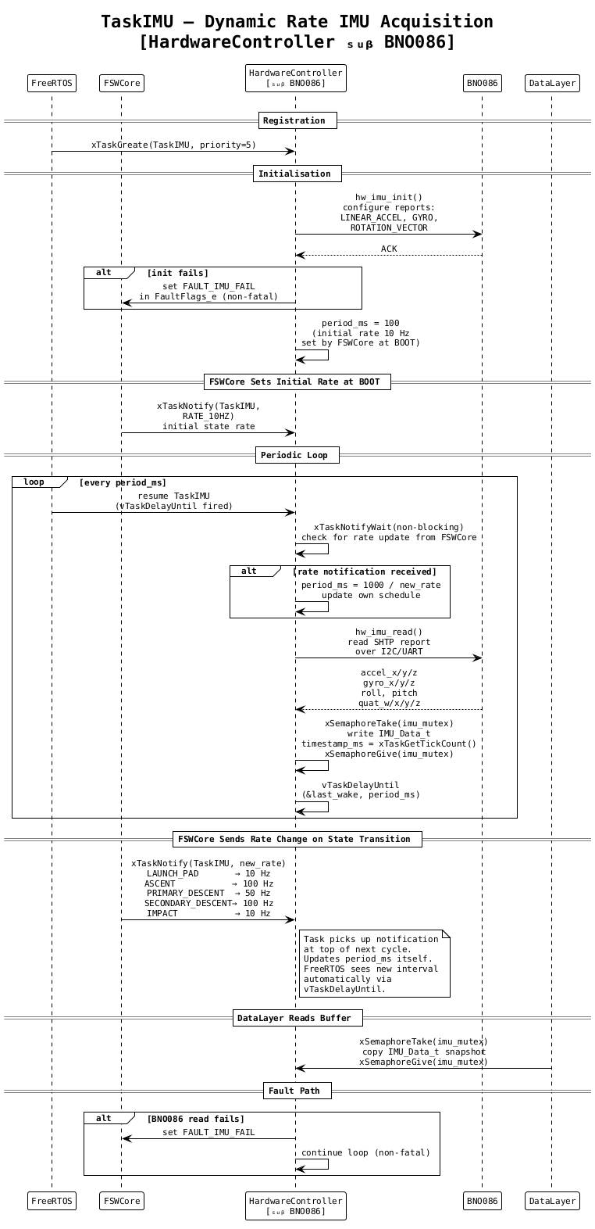
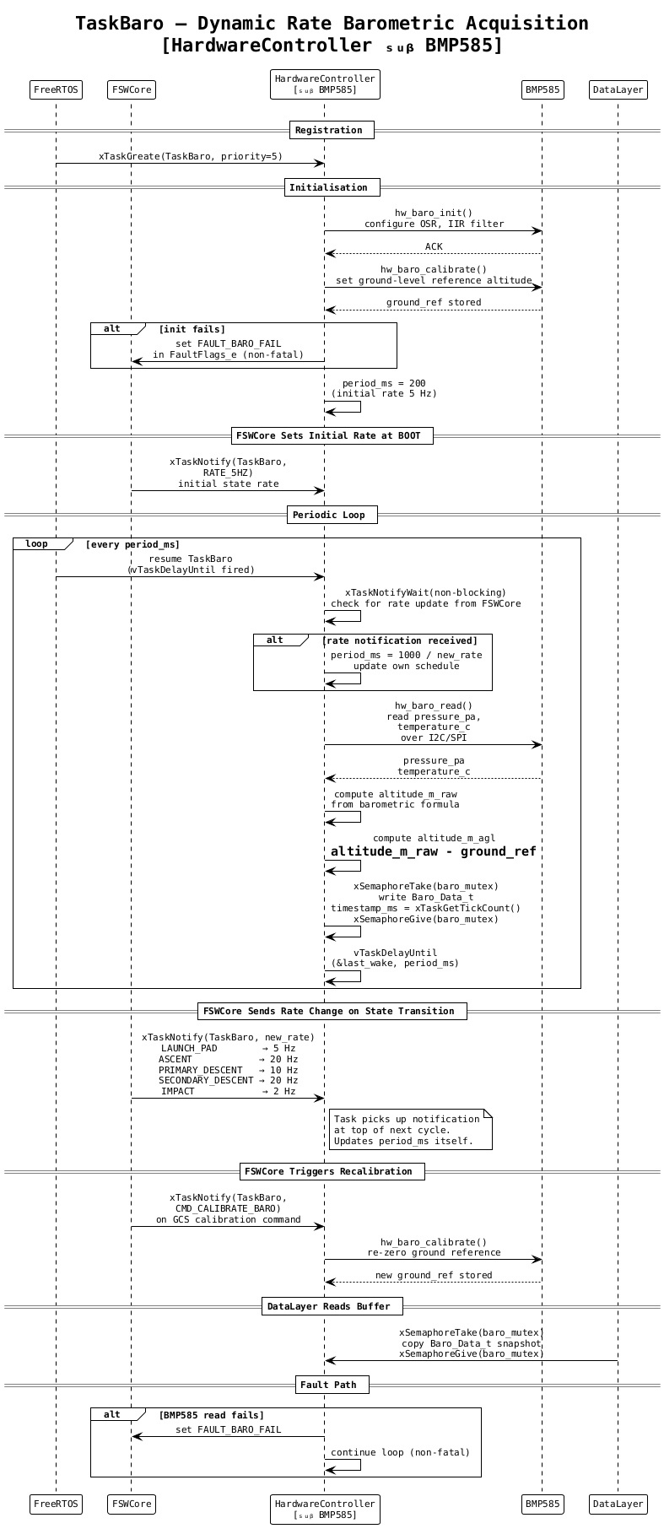
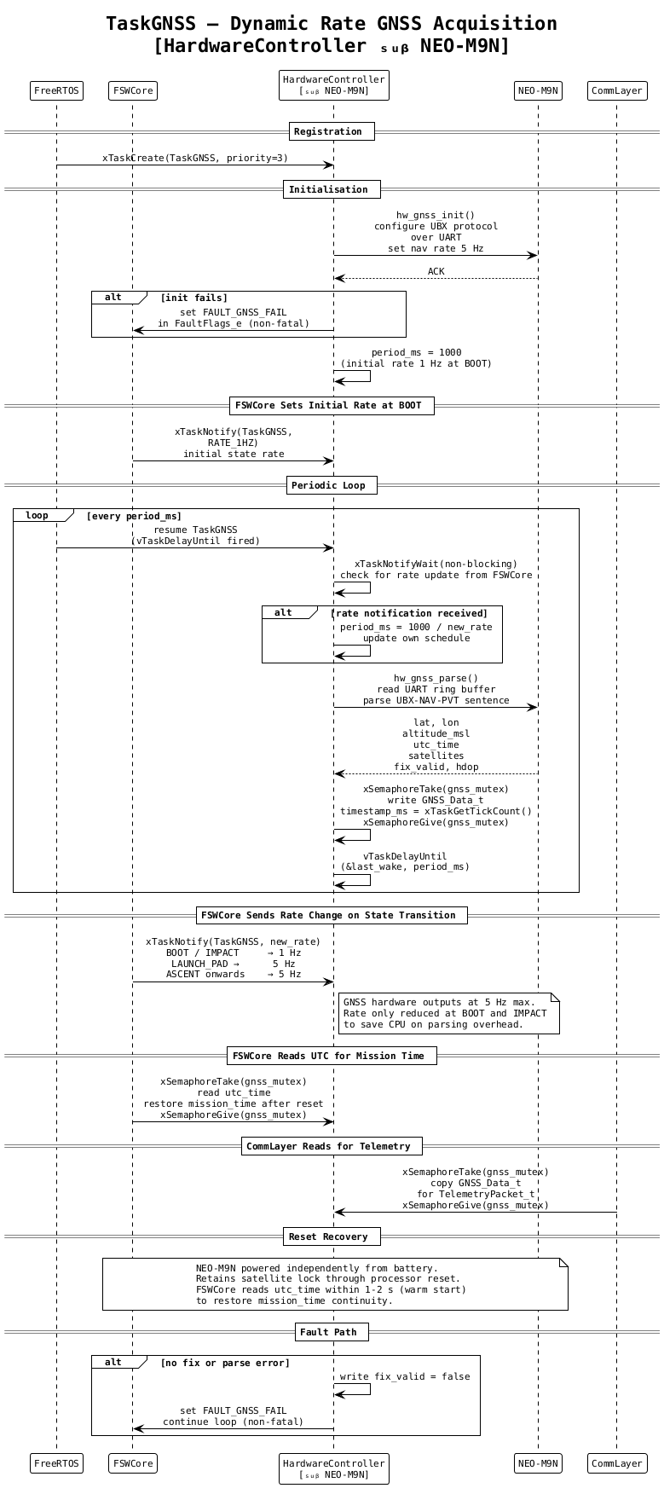

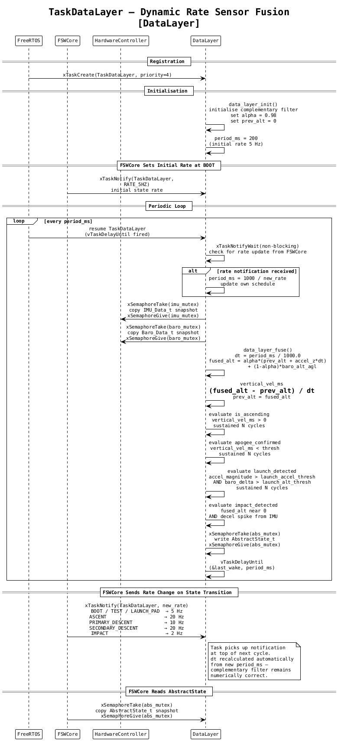

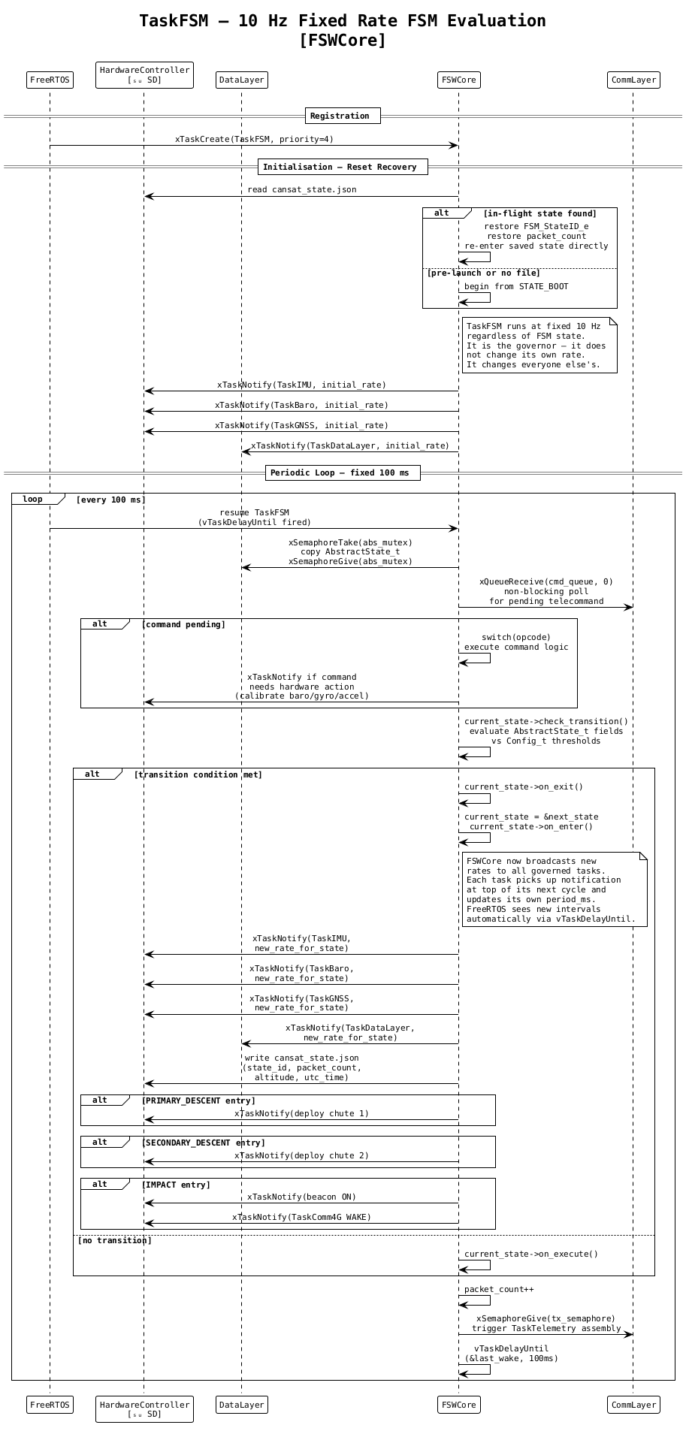
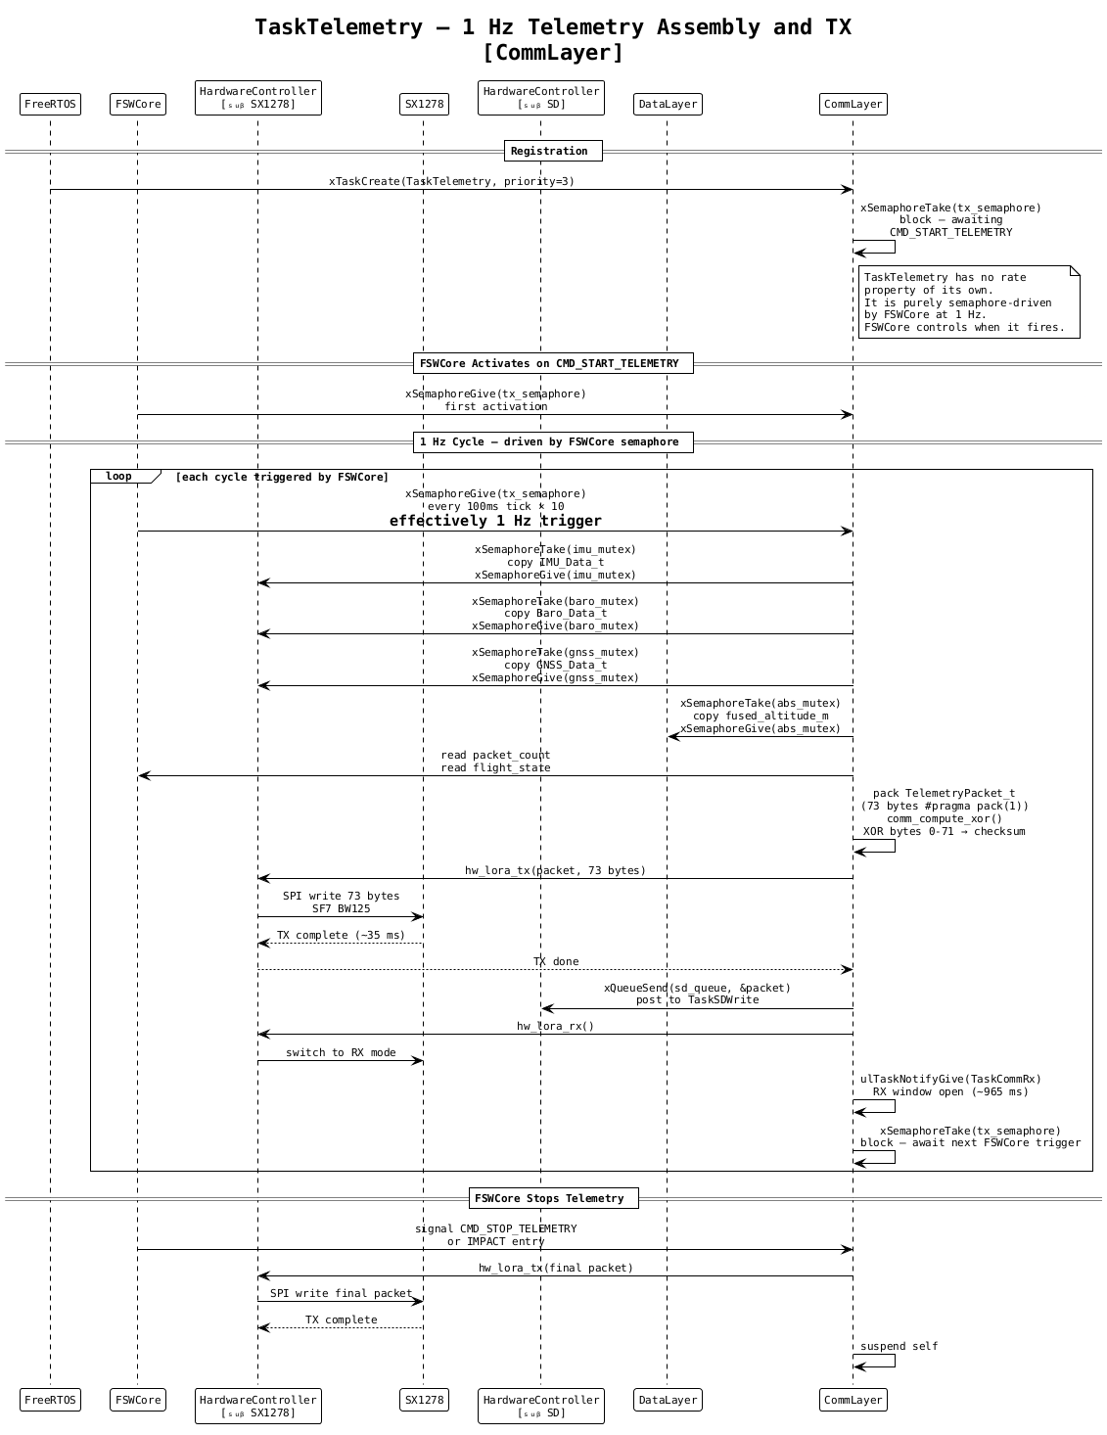

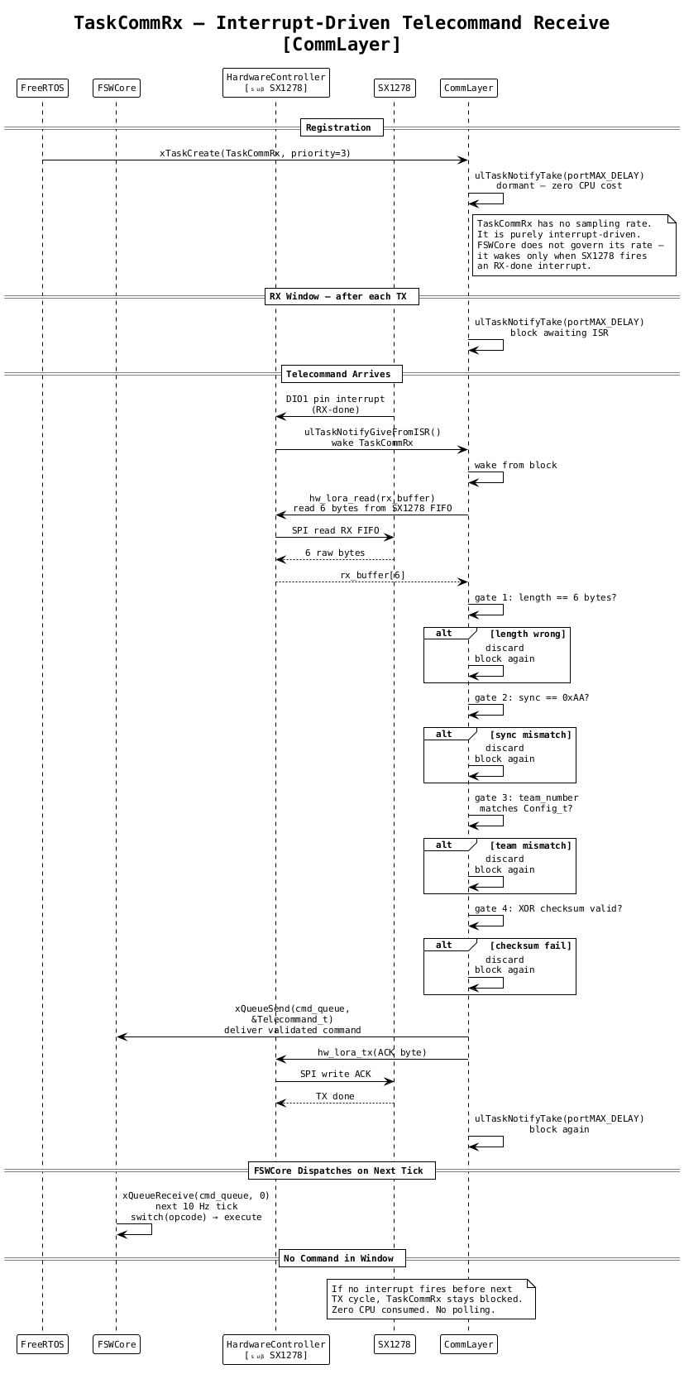

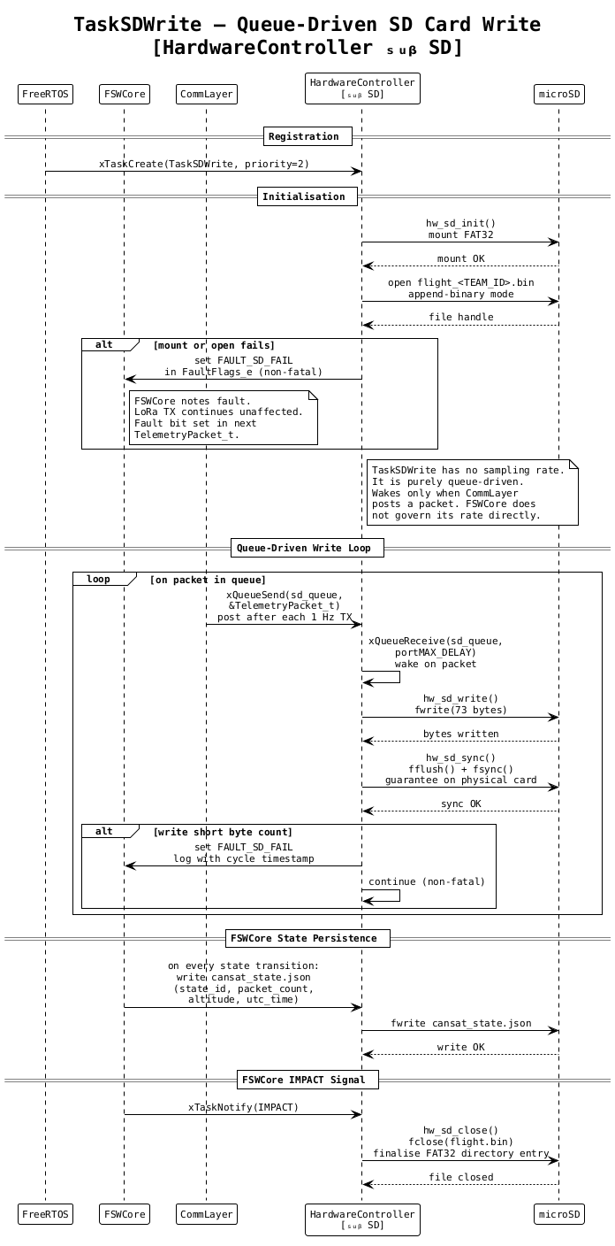

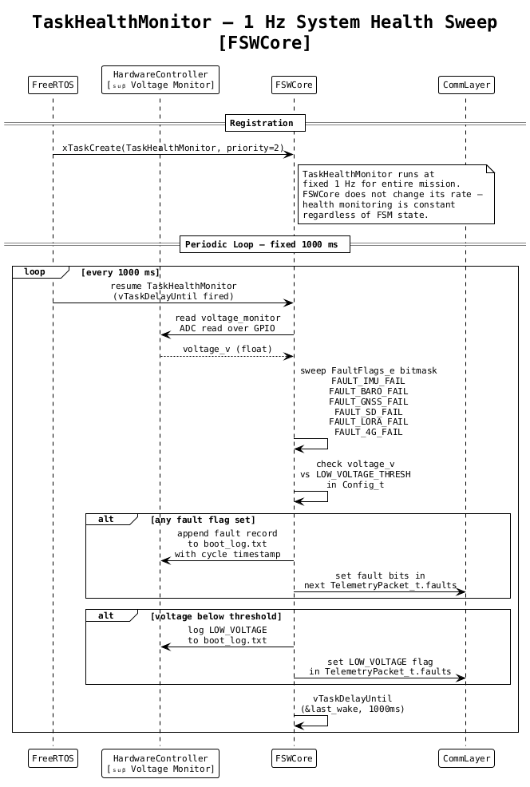

6.5 Telemetry and Telecommand Details

6.5.1 Communication Architecture Overview
The Model Rocket Flight Software implements a bidirectional RF communication link between the Onboard Telemetry Unit and the Ground Control Station using the Ra-01H SX1262 LoRa module (or XBee/Zigbee transceiver) operating at 868 MHz.
The link carries two distinct traffic classes. Downlink telemetry flows from the Onboard Telemetry Unit (OTU) to the GCS at 1 Hz carrying all sensor, state, and housekeeping data. Uplink telecommands flow from the GCS to the OTU carrying operator instructions for calibration, state transitions, and transmission control. The radio transmits the telemetry packet and then immediately switches to receive mode, listening for any incoming telecommand. This half-duplex timing arrangement ensures telemetry is never interrupted by command reception and commands are never missed.
The Communication Layer within the FSW layered architecture is solely responsible for managing both traffic classes. It provides a clean upward interface to FSW Core for command delivery and state reporting, and a clean downward interface to the Hardware Controller Layer for physical transmission and reception.

6.5.2 Downlink Telemetry

Transmission Trigger and Rate
Upon receiving the CMD_START_TELEMETRY telecommand from the GCS, the FSW begins transmitting one telemetry packet per second continuously. Telemetry is not transmitted autonomously at power-on. The GCS must explicitly command transmission. Transmission continues until a CMD_STOP_TELEMETRY command is received or the IMPACT state is reached, at which point the final packet is transmitted, the SD card is finalized, and the recovery beacon is activated.

Serialization Approach — Direct Binary Serialization
To minimize air time and duty cycle, Direct Binary Serialization was selected for over-the-air transmission, combined with ASCII CSV regeneration on the GCS side.
All telemetry fields are packed into a fixed-layout C struct and the raw bytes of that struct are transmitted over the link. The total struct size is 73 bytes, which reduces air time and duty cycle to approximately 3 percent, well within ISM band self-management guidelines.
On the GCS side, the received 73 bytes are validated and then deserialized back into named fields. The GCS Ground Station software then regenerates the ASCII CSV line from those fields and writes it to the log file. The output format is fully compliant with the 16 mandatory fields specified in Annexure-2 of the guidelines:
<TEAM ID>, <TIME STAMPING>, <PACKET COUNT>, <ALTITUDE>, <PRESSURE>, <TEMP>, <VOLTAGE>, <GNSS TIME>, <GNSS LATITUDE>, <GNSS LONGITUDE>, <GNSS ALTITUDE>, <GNSS SATS>, <ACCELEROMETER DATA>, <GYRO SPIN RATE>, <FLIGHT SOFTWARE STATE>, <ANY OPTIONAL DATA>

Telemetry Struct Definition
The telemetry packet is defined as a packed C struct to guarantee no padding bytes are inserted between fields:
#pragma pack(1)
typedef struct {
uint16_t team_number; // 2 bytes -- numeric team ID (e.g. 42)
uint32_t mission_time; // 4 bytes -- seconds since power-on
uint16_t packet_count; // 2 bytes -- sequential cycle counter
float altitude; // 4 bytes -- altitude relative to ground AGL (m)
float pressure; // 4 bytes -- atmospheric pressure (Pa)
float temperature; // 4 bytes -- temperature (Celsius)
float voltage; // 4 bytes -- system voltage (Volts)
uint32_t gnss_time; // 4 bytes -- HHMMSS as integer
float latitude; // 4 bytes -- decimal degrees
float longitude; // 4 bytes -- decimal degrees
float gnss_altitude; // 4 bytes -- metres MSL
uint8_t gnss_sats; // 1 byte -- satellite count
float accel_x; // 4 bytes -- acceleration X (m/s²)
float accel_y; // 4 bytes -- acceleration Y (m/s²)
float accel_z; // 4 bytes -- acceleration Z (m/s²)
float gyro_spin_rate; // 4 bytes -- spin rate (deg/s)
uint8_t flight_state; // 1 byte -- FSW state enum as uint8
uint8_t checksum; // 1 byte -- XOR of bytes 0 through 71
} __attribute__((packed)) TelemetryPacket_t;
#pragma pack()

Telemetry Field Summary
S.No. | Field | Resolution | Source | Bytes
1 | team_number | Integer | Hardcoded config | 2
2 | mission_time | 1 second | System Clock | 4
3 | packet_count | Integer | FSW Core | 2
4 | altitude | 0.1 m | Data Layer fused (Primary altimeter) | 4
5 | pressure | 1 Pa | BMP580/BMP585 | 4
6 | temperature | 0.1 °C | BMP580/BMP585 | 4
7 | voltage | 0.01 V | Voltage Monitor ADC | 4
8 | gnss_time | HHMMSS | NEO-M9N | 4
9 | latitude | 0.0001° | NEO-M9N | 4
10 | longitude | 0.0001° | NEO-M9N | 4
11 | gnss_altitude | 0.1 m | NEO-M9N | 4
12 | gnss_sats | Integer | NEO-M9N | 1
13-15 | accel_x/y/z | 0.01 m/s² | MPU6050/BNO086 | 12
16 | gyro_spin_rate | 0.1°/s | MPU6050/BNO086 (Mechanical Gyro Spin) | 4
17 | flight_state | Enum uint8 | FSW Core (FSM State) | 1
18 | checksum | XOR uint8 | Comm. Layer | 1
 | Total |  |  | 73 bytes

Packet Integrity — XOR Checksum
A single XOR checksum byte is computed over all 72 preceding bytes of the struct and stored as the final field before transmission. The receiver recomputes this XOR independently and compares it against the received checksum byte to catch any bit-flip corruption before deserialization is attempted.

Packet Counter and Drop Detection
The packet_count field is an unsigned 16-bit integer maintained by FSW Core that increments by one every telemetry cycle unconditionally. GCS detects dropped or corrupted packets by verifying that each received packet's counter is exactly one greater than the previous accepted packet's counter.

GCS Deserialization and CSV Regeneration
On the GCS side, the received 73 bytes are validated through length, checksum, and team number filters. Once validated, the GCS ground software deserializes the fields, formats them to the required resolution, prepends the full TEAM_ID string (e.g. 2026 IN-SPACe-XXX), and writes it as an ASCII CSV row to the Flight_<TEAM_ID>.csv file.

Telemetry Data Flow
Raw sensor readings are collected every cycle from the barometric sensor, IMU, GNSS module, and voltage monitor. The Data Layer processes these to produce clean abstract estimates including the fused altitude. FSW Core evaluates state machine transition conditions, increments the packet counter, and updates the flight_state. The Communication Layer computes the XOR checksum and writes the 73-byte raw block to the RF transmitter and the SD card submodule.

Transmission Cycle Timing Budget
The 1 Hz main loop completes sensor reads, data fusion, FSM state evaluation, checksum computation, SD card writing, and RF transmission within approximately 50 milliseconds, leaving approximately 950 milliseconds of the cycle budget in receive mode listening for telecommands.

6.5.3 Uplink Telecommand System

Design Approach — Hexadecimal Packetized Command Structuring
Telecommands from the GCS to the rocket use Hexadecimal Packetized Command Structuring. Each command is encoded as a fixed 6-byte binary packet in which a unique one-byte hexadecimal opcode identifies the command to be executed.

Telecommand Packet Structure
The telecommand packet is a fixed 6-byte sequence:
- Sync Byte (0xAA)
- Team Number (16-bit unsigned integer) - 2 bytes
- Opcode (8-bit command identifier) - 1 byte
- Parameter (8-bit argument, or 0x00 if unused) - 1 byte
- Checksum (XOR checksum of preceding 5 bytes) - 1 byte

Opcode Table
Opcode | Command | Valid FSW States | Action
0x01 | CMD_START_TELEMETRY | LAUNCH_PAD | Begin 1 Hz binary telemetry transmission
0x02 | CMD_STOP_TELEMETRY | Any | Halt RF telemetry transmission
0x03 | CMD_CALIBRATE_BARO | LAUNCH_PAD | Zero BMP580/BMP585 altitude to ground level
0x04 | CMD_CALIBRATE_GYRO | LAUNCH_PAD | Zero gyroscope bias offsets
0x05 | CMD_CALIBRATE_ACCEL | LAUNCH_PAD | Zero accelerometer offsets
0x06 | CMD_ENTER_TEST | BOOT | Transition FSW to TEST_MODE
0x07 | CMD_ENTER_LAUNCHPAD | TEST_MODE | Transition FSW to LAUNCH_PAD
0x08 | CMD_SWITCH_CHANNEL | Any | Switch transceiver to backup RF channel
0x09 | CMD_TRIGGER_SEP | ASCENT | Manual override to trigger payload separation

Telecommand Receive Window and Half-Duplex Management
Because the RF transceiver operates in half-duplex mode, the radio explicitly switches to receive mode for 950 milliseconds of each 1 Hz cycle. If a command arrives, the radio raises a receive-complete interrupt, the Hardware Controller reads the bytes, and the Communication Layer processes and executes the command on the next FSM tick.

Receiver Validation and Dispatch
Received bytes are passed to the Communication Layer to apply length verification, sync byte check, team number matching, and XOR checksum validation. Only packets passing all four gates are dispatched to the opcode switch-case for execution.

6.5.4 RF Interference Mitigation Plan
To prevent inter-team RF interference at the launch site, the following measures are incorporated:
- Sync Word Isolation: The transceiver sync word is set to a team-specific value derived from the assigned team number.
- Software Filtering: The team number is embedded in both telemetry and command packets for software-level verification.
- Low Duty Cycle: Telemetry packets occupy a very low transmission time (30-35ms), keeping the radio silent 97% of the cycle.
- Frequency Agility: Backup RF channels (e.g. 861.5 MHz and 869.0 MHz) are pre-configured in firmware and can be dynamically activated via GCS command if primary frequency interference is detected.

6.6 Data Storage and Handling

Storage Strategy
To prevent data loss in case of telemetry link failure, the flight software performs an unconditional parallel write of every telemetry packet to the onboard SD card. Storing binary structs rather than ASCII CSV ensures compactness (reducing flight log size by half) and speed (writing 73 raw bytes avoids the overhead of sprintf).

Onboard File Structure
Three files are maintained on the FAT32 SD card:
- flight_<TEAM_ID>.bin: The binary flight log appended with one 73-byte telemetry struct every cycle.
- rocket_state.json: The FSW state persistence file written at every state transition to recover the operating state after reset.
- boot_log.txt: A plain text log of boot events, fault flags, state transitions, and SD write errors.

Standard SD Card Write Process
The SD card is formatted as FAT32 and interfaced via the SPI bus. It is mounted once at BOOT. If mounting fails, the FSW Core raises a non-fatal fault flag but continues initialization and operation normally, ensuring SD card faults never block the FSM or telemetry. The binary log file is kept open throughout the mission to minimize latency and avoid FAT32 directory entry corruption from power cuts during close operations.

FSW State Persistence Across Processor Reset
The FSW implements mid-flight reset recovery through the rocket_state.json file. The file records the current state, current packet counter, last known fused altitude, and GPS UTC timestamp at the time of transition.
Upon reboot, FSW Core reads rocket_state.json. If it contains an in-flight state (ASCENT, PAYLOAD_SEP, DESCENT, or AEROBREAK_RELEASE), FSW Core restores the FSM to that state directly, restores the packet counter, and resumes telemetry transmission within 5 seconds of reboot without traversing the pre-launch sequence.

Post-Flight Data Retrieval
Following landing and recovery, the binary file flight_<TEAM_ID>.bin is retrieved from the SD card. A conversion utility script on the GCS reads the binary file sequentially, validates the checksums, and regenerates the GCS-compliant Flight_<TEAM_ID>.csv for judge evaluation.

Data Integrity Measures Summary
Measure | Implementation | Failure Mode Addressed
XOR Checksum | Computed over bytes 0-71, stored as byte 72 | RF bit-flip corruption and SD read errors
Four-Gate GCS Validation | Length, checksum, team number, and deserialization filters | Malformed packets, corruption, and inter-team interference
fflush/fsync on SD Write | Called immediately after every binary write | Data loss from power cut before buffer drain at impact
Unconditional SD Write | Runs every cycle from BOOT | RF link loss during any flight phase
State Persistence File | Written to rocket_state.json at every state transition | Mid-flight processor reset causing state and counter loss
RF Sync Word | Set to team-specific value in transceiver hardware | Physical-layer inter-team interference

6.7 Simulation Mode Strategy

Overview
The TestAndSim suite is a dedicated FSW module activated by a compile-time flag in config.h for ground testing. When active, it replaces sensor acquisition tasks with simulation counterparts while keeping storage, FSM logic, and telemetry tasks identical to flight firmware. Rather than acquiring live sensor data, it injects procedurally generated data directly into the shared sensor buffers, making the simulation entirely transparent to the rest of the FSW.

SimDriver_t
All simulation states are owned by the SimDriver_t struct, which holds simulated readings, scenario identifiers, simulation tick counters, and a fault injection field of type FaultFlags_e to simulate sensor failures. The noise model and physical model parameters are configurable to allow deterministic regression runs and randomized stress testing.

Some Example Scenarios
- Nominal Flight Scenario: Models a complete mission profile from BOOT through IMPACT following the expected altitude (1000m) and velocity envelope.
- Apogee Edge Case Scenario: Models a slow, shallow apogee profile to test apogee detection debouncing in the Data Layer.
- Launch Detection Edge Case: Applies vibration-level accelerations to verify that launch detection logic ignores handling shock.
- Processor Reset Scenario: Injects a simulated reset during ASCENT to verify that FSM state and packet counters are successfully restored from rocket_state.json.

6.8 Test Methodology

Overview
The FSW test strategy is structured across unit testing of individual module functions (white-box) and integration testing of the complete FSW pipeline (black-box) via the TestAndSim suite.

White-Box Unit Testing
Executed on the development host without requiring FreeRTOS or physical hardware to verify:
- FSM transition conditions in FSW Core.
- Complementary filter correctness in the Data Layer.
- Packet serialization and checksum calculations in the Communication Layer.
- SD write sequences and fault flag propagation.

Black-Box Integration Testing
Integration tests drive the FSW through TestAndSim scenarios, evaluating:
- FSM Correctness: Verifies the FSM traverses states in the correct order (BOOT -> TEST_MODE -> LAUNCH_PAD -> ASCENT -> PAYLOAD_SEP -> DESCENT -> AEROBREAK_RELEASE -> IMPACT) with no skipped or repeated transitions.
- Packet Counter Integrity: Verifies packet counters increment by exactly one and recover correctly from reset.
- Boundary Condition Compliance: Tests all FSM transition thresholds (launch, apogee, 600m deployment, touchdown) at boundary limits.
- Fault Tolerance: Verifies the system enters degraded modes but never stalls or loops indefinitely.

6.9 Software Reset Loop

Reset Detection and State Recovery
On every power-on or reset, the first action of TaskFSM is to attempt to read rocket_state.json from the SD card.
- File does not exist: Clean boot. FSW proceeds normally: BOOT -> TEST_MODE -> LAUNCH_PAD.
- Pre-launch state present: Reset occurred before flight. The FSW restarts the pre-launch sequence.
- In-flight state present: Mid-flight reset detected. FSW skips the pre-launch sequence, restores the FSM state, packet counter, and fused altitude, and resumes telemetry within 5 seconds.

Watchdog Timer
A hardware watchdog timer is configured with a 2000ms window. TaskFSM feeds the watchdog once per 10 Hz cycle. If any task deadlocks or the scheduler hangs, the watchdog forces a reset, triggering the state recovery sequence.

6.10 Proto Version Testing Details
Proto version testing is conducted on assembled hardware before final integration to verify that each subsystem functions correctly under realistic conditions.

Sensor Bring-Up Tests
Each sensor is verified individually:
- BMP580/BMP585: Bench test confirms ambient pressure readings and verifies that ground reference zeroes correctly.
- BNO086: UART output is verified at 100 Hz to confirm accelerometer, gyroscope, and quaternion fields are populated without dropouts.
- NEO-M9N: Cold-start fix acquisition test is run outdoors to confirm satellite lock and sentence parsing.
- Dual Altimeters: Confirm signals from the primary altimeter and the backup altimeter are correctly registered.

FSM State Transition Test
With all sensors connected, the FSW is run through a simulated mission on the bench by manually injecting conditions that trigger each state transition. Acceleration is simulated by shaking the unit, and the 600m altitude trigger for AEROBREAK_RELEASE is tested by adjusting the ground reference offset. The transitions are verified by observing the flight_state in received telemetry.

Telemetry Link Test
The RF link is tested at increasing separation distances. The packet loss rate is estimated by inspecting gaps in the received packet count to confirm adequate link margin for the maximum altitude.

SD Card Write Verification
A 10-minute continuous run is conducted with the FSW active. The binary log file is converted post-run to verify no missing packets or SD write errors. The SD card is physically removed mid-run to verify that the non-fatal fault path is triggered correctly and telemetry continues uninterrupted.

Reset Recovery Test
With the FSW running in ASCENT state, the reset button is pressed. The time from reset to first received telemetry packet must be under 5 seconds, the packet counter must resume from its saved value, and the FSM state must recover to ASCENT.

Payload Deployment Test (Ground Simulation)
A ground-based Payload Deployment Test is performed to validate the ejection mechanism:
- The model rocket is fully assembled on the test bench with the payload (CAN-7U sized satellite mock) loaded inside the payload bay and secured by the servo-driven spring latch mechanism.
- The flight computer is connected to the test harness, and pseudo-sensor values (simulating a nominal launch, ascent, and apogee profile) are injected.
- The FSW must process the injected data, transition through LAUNCH_PAD -> ASCENT -> PAYLOAD_SEP upon detecting the simulated apogee at 1000m.
- The software must generate the servo command to release the latch, triggering the spring-based nosecone opening and payload ejection.
- The test is repeated. Success is defined as:
  - 100% successful state transitions to PAYLOAD_SEP based on simulated apogee detection.
  - Deterministic servo actuation within 100 milliseconds of state entry.
  - Clean mechanical release and deployment of the payload and primary parachute mock without jamming.
  - Active telemetry reporting throughout the entire sequence.

